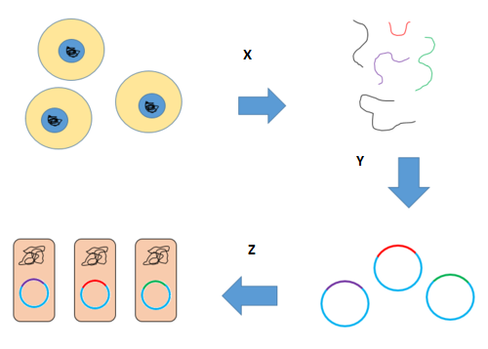
Which step X represents in the given diagram
A. DNA is extracted from cells and digested with a restriction enzyme
B. DNA fragments are inserted into cloning vectors
C. Bacterial cells are transformed with vectors
D. DNA ligase
ANSWER: A

Which step Y represents in the given diagram
A. DNA is extracted from cells and digested with a restriction enzyme
B. DNA fragments are inserted into cloning vectors
C. Bacterial cells are transformed with vectors
D. DNA ligase
ANSWER: B

Which step Z represents in the given diagram
A. DNA is extracted from cells and digested with a restriction enzyme
B. DNA fragments are inserted into cloning vectors
C. Bacterial cells are transformed with vectors
D. DNA ligase
ANSWER: C
A ________is a collection of the total genomic DNA from a single organism.
A. Gene
B. allele
C. genomic library
D. library
ANSWER: C
The approximate number of human genes on 23 pairs of chromosomes is:
A. 10,000 to 15,000
B. 20,000 to 25,000
C. 30.000 to 35.000
D. 45,000 to 50,000
ANSWER: C
The study of human genome has enormous potential_______.
A. losses
B. hazards
C. benefits
D. None
ANSWER: C
HGP stands for
A. Human Gene Processing
B. Human Gene Percentage
C. Human Genome Project
D. Human genetic Percentage
ANSWER: C
The__________ was an international scientific research project with the goal of determining the base pairs that make up human DNA, and of identifying, mapping and sequencing all of the genes of the human genome from both a physical and a functional standpoint
A. Human Genome Project
B. HGP
C. both a and b
D. none
ANSWER: C
who was the first director of human genome research institute
A. Pasture
B. Leeuwenhoek
C. James Watson
D. Mandel
ANSWER: C
Which of the following was the goal of HGP?
A. Construct genetic and base sequence map of human genome
B. store this information in databases
C. improve tools for data analysis
D. All of these
ANSWER: D
According to HGP, genetic similarity between all humans is
a) 90%
b) 95%
c) 99.9%
d) 99.5%
ANSWER: C
___________is a collection of the total genomic DNA from a single organism
a) Genomic library
b) Protein production
c) Antibiotics
d) Regeneration
ANSWER: A
Which DNA is restricted to making a genomic library?
a) Genomic
b) Plasmid
c) Phage
d) Plant
ANSWER: A
Which of the following is a suitable host for the process of cloning in Human Genome Project (HGP)?
a) Virus
b) All types of fungi
c) Bacteria
d) Protozoan
ANSWER: C
Based on whose principle were the DNA molecules fragmented in the year 1977?
a) Maurice Wilkins
b) Rosalind Franklin
c) James Watson
d) Frederick Sanger
ANSWER: D

